**Database Project**

**Project Title: Airline Reservation Database**

Group Member:

Prem Chand Saini (201452019)

Ravi Kumar Patel (201452056)

Ajit Kumar Jain (201452064)

Jitendra Singh Rajput (201452005)

**INTRODUCTION**

This project on Airline Database Management System is the online of registration process of airline system. The system is able to provide information like Flight detail, passenger’s information, fair detail, and flight path detail. The system also allows us to add records when a passenger reserves a ticket. For data storage and retrieval we are using PostgreSQL server. It enables us to add any number of records in our database.

**Objective of the project:**

* To provide information about reservation in airlines management.
* To help airlines system in making their business more efficient.
* An added attraction for their potential customers.
* It will be more user friendly and accurate and optimal database.

**Data Requirement:**

For this we have created different entities.

* **Company**

It has attributes i.e. c_id (Primary key) it is unique, c_name (company name), head_quarter, company_url.

* **Flight_status**

It has attributes i.e flight_status_id (Primary key), it is unique flight_status_name like international or domestic

* **Flight_detail**

It has attributes i.e flight_no (Primary key),flight_name ,c_id, flight_type_id

We are assuming that all flight_no are unique for all companies.

* **Route**

It has attributes i.e. route_id (Primary key), Source, Destination.

We assuming this entities cover airports.

Here will be all possible route detail.

Example.

{A -> B->C->D}

For this

{A->B,

A->C,

A->D,

B->C,

B->D,

C->D }

* **Days**

It has attributes i.e. day_id(Primary key) ,day_name all week days.

* **All_path**

It has attributes i.e. flight_no (primary key), rout_id.

This is a particular flight all path details.

If flight_no 1111 (A->B->C->D)

For this

{A->B,

A->C,

A->D,

B->C,

B->D,

C->D }

* **Flight_route**

It has attributes i.e. flight_no, flight_route_id, rout_id, dept_day, depart_time, arrival_time.

This entities help for the particular flight path in orderwise.

If flight_no 1111 (A->B->C->D)

{

1111, 1 , A->B,

1111, 2 , B->C,

1111, 3 , C->D}

* **Users**

It has attributes i.e. user_id (primary key) ,{ fname , lname} (composite attribute) , gender , dob , emailid , contact_no , address , country.

* **Class**

It has attributes class_id (Primary key), class_name.

This is two type class in this database system one is business and other is general.

* **Ticket**

It has attributes i.e pnr_no (primary key) this will be unique in our database, user_id, flight_no, class_id , route_id , booking_date , journey_date.

* **Passenger_status**

It has attributes i.e passenger_status_id (primary_key), passenger_status_name. In this entity three type of status below 3 year age and more than this and pwd.

* **Passenger**

It has attributes i.e. {pnr_no ,seat_no(weak entity)} (primary key) , {fname ,lname} (composite attribute) , gender , age.

This is weak entity dependent on ticket entity.

* **fare_detail**

It has attributes i.e primarykey (flight_no, route_id, class_id, passenger_status_id) fare. This entity has all foreing key

**Queries for Database:**

1. Given company name find out all flight details?
2. Given the flight number find out route (source, destination)?
3. Given a day find out all airports and flight details?
4. Given a route find out all type of fare?
5. Given a source and destination find out flight details?
6. Find out Max fare with flight Detail?
7. Given PNR find out all details?
8. Find out how many ticket book for particular date for Mumbai?
9. Find out how many ticket book for particular date from Delhi to Mumbai?
10. Find out how many ticket book for particular date?
11. Number of flight a particular company?
12. Find Out User detail those have maximum booking?
13. How many seat book of a particular flight?
14. Update user profile?
15. Find out flight detail who going Monday and from Delhi to Mumbai?
16. Find out PNR No which have Booked maximum number of sheets?
17. Find out the total no ticket of a particular journey date?
18. Find out the route-id which have maximum flight?

**SQL Query**

**Q1.**Given company name find out all flight details?

**Company Name:** Indigo

**SQL:** select flight_no,flight_name from company natural join flight_detail where c_name='Indigo';

**Output:**

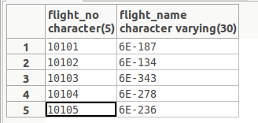

**Q2.**Given the flight number find out route (source,destination)?

**Flight No: 10101**

**SQL: select flight_name,source,destination** from (select * from flight_detail natural join all_path where flight_no='10101')as r1 natural join route;

**Output:**

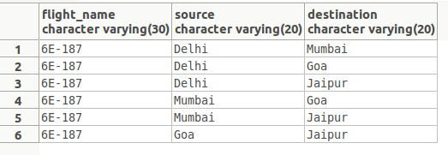

**Q3.**Given a day find out all airports and flight details?

**Day: Monday**

**SQL:** select flight_no, flight_name,depart_time,arrival_time,source,destination from(select * from(select * from flight_detail natural join flight_route) as r1 natural join days where day_name='Monday')as r2 natural join route;

**Output:**

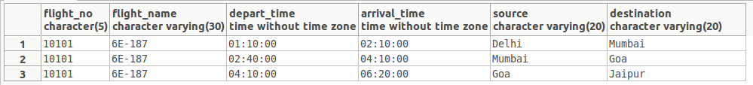

**Q4** Given a route find out all type of fare?**.**

**Route:** Ahmedabad to Channai

**SQL:** select flight_no,fare,passenger_status_name from(select * from fare_detail natural join route)as r1 natural join passenger_status where source='Ahmedabad' and destination='Channai';

**Output:**

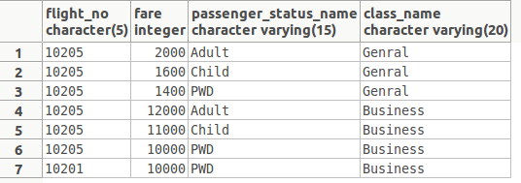

**Q5.**Given a source and destination find out flight details?

**Route:** Delhi to Mumbai

**SQL:** select flight_no,flight_name,source,destination from (select * from flight_detail natural join all_path)as r1 natural join route where source='Delhi' and destination='Mumbai';

**Output:**

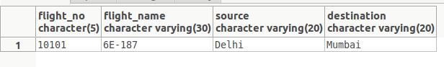

**Q6.**Find out Max fare with flight Detail?

**SQL:** select class_id,flight_no,passenger_status_id,route_id,fare from fare_detail where 7

**Output:**

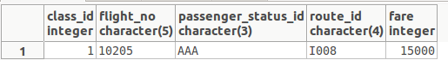

**Q7**.Given PNR find out all details?

**--PNR No: AAAAA00001**

**SQL:** select pnr_no,fname,lname,gender,age,flight_no,flight_name,source,destination,ticket_date,journey_date,fare from(select * from((select * from ticket natural join passenger where pnr_no='AAAAA00001') as r1 natural join

(select * from flight_detail natural join route) as r2)) as r3 natural join fare_detail;

**Output:**

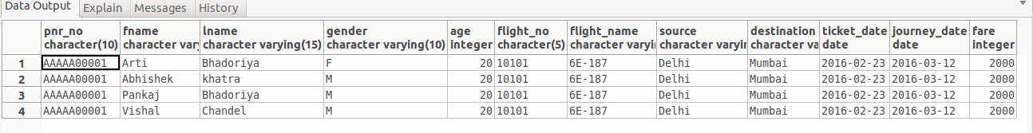

**Q8.** Find out how many ticket book for particular date for Mumbai?

**SQL:** select count(seat_no)as No_of_Ticket from(select * from passenger natural join ticket)as r1 natural join route where ticket_date='2016-02-23' and destination='Mumbai';

**Output:**



**Q9.**Find out how many ticket book for particular date from Delhi to Mumbai?

**SQL:** select count(pnr_no) from(select * from passenger natural join ticket where journey_date='2016-03-12')as r1 natural join route where source='Delhi' and destination='Mumbai';

**Output:**



**Q10.** Find out how many ticket book for particular date?

SQL:

select count(pnr_no)as No_of_Ticket from passenger natural join ticket where ticket_date='2016-02-23';

Output:



**Q11**. Number of flight a particular company?

SQL: c_id,count(select flight_no),c_name from (company natural join flight_detail) group by c_id;

Output:

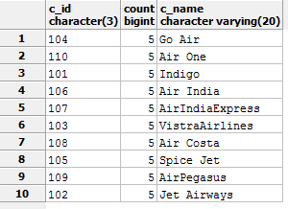

Q12. Find Out User detail those have maximum booking?

SQL: select * from users natural join (select user_id,count(pnr_no) from ticket group by user_id having count(pnr_no) >= all

(select count(pnr_no) from ticket group by user_id)) as r;

Output:



Q13. How many seat book of a particular flight?

SQL: select count(pnr_no) from passenger natural join ticket where journey_date='2016-03-12';

Output:

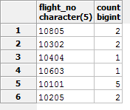

Q14. Update profile

SQL: update users Set fname='Sakshi',lname='Dubay',emailid='skdubay998@gmail.com',contact_no='9865423432',

where fname='name';

Q15. Find out flight detail who going Monday and from Delhi to Mumbai?

SQL: select flight_no,flight_name,source,destination,depart_time,arrival_time,day_name from((select * from flight_detail natural join flight_route)as r1 natural join (select * from all_path natural join route)as r2) as r3 natural join days where day_name='Monday' and source='Delhi' and destination='Mumbai';

Output:



Q16. Find out PNR No which have Booked maximum number of sheets?

SQL: select pnr_no,count(seat_no) as cc from (select * from flight_route join ticket on(flight_route.route_id=ticket.route_id and

flight_route.flight_no=ticket.flight_no )) as r natural join passenger group by pnr_no having count(seat_no) >= all ( select count(seat_no) from

(select * from flight_route join ticket on(flight_route.route_id=ticket.route_id and

flight_route.flight_no=ticket.flight_no)) as r natural join passenger group by pnr_no);

Output:



Q17. Find out the total no ticket of a particular journey date?

SQL: select count(pnr_no) from passenger natural join ticket where journey_date='2016-03-12';

Output:



Q18. Find out the route-id which have maximum flight?

SQL: select route_id,count(*) from flight_route natural join all_path group by route_id having count(*) >= all

(select count(*) from flight_route natural join all_path group by route_id);

Output:

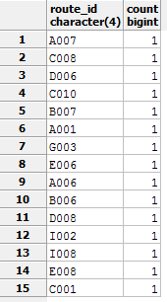

**Functional dependencies of different entities or relation:**

Company

|  |  |  |  |
| --- | --- | --- | --- |
| **c_id** | c_name | head_quarter | company_url |

### FD's

c_id → c_name

c_id → head_quarter

c_id → company_url

BCNF

flight_status

|  |  |
| --- | --- |
| **flight_status_id** | flight_status_name |

**FD's**

flight_status_id → flight_status_name

BCNF

flight_detail

|  |  |  |  |
| --- | --- | --- | --- |
| **flight_no** | flight_name | c_id | flight_status_id |

**FD's**

flight_no → flight_name

flight_no → c_id

flight_no → flight_status_id

BCNF

route

|  |  |  |
| --- | --- | --- |
| **route_id** | source | destination |

**FD's**

route_id → source

route_id → destination

BCNF

days

|  |  |
| --- | --- |
| **day_id** | day_name |

**FD's**

day_id → day_name

BCNF

all_path

|  |  |
| --- | --- |
| flight_no | route_id |

**FD's**

Not exist

flight_route

|  |  |  |  |  |  |
| --- | --- | --- | --- | --- | --- |
| **flight_no** | **flight_route_id** | route-id | dept_day | depart_time | arrival_time |

**FD's**

{ flight_no, flight_route_id }→ route-id

{ flight_no, flight_route_id }→ dept_day

{ flight_no, flight_route_id }→ depart_time

{ flight_no, flight_route_id }→ arrival_time

BCNF

user

|  |  |  |  |  |  |  |  |  |
| --- | --- | --- | --- | --- | --- | --- | --- | --- |
| **user_id** | fname | lname | gender | dob | emailid | contact_no | address | country |

FD's

user_id → fname

user_id → lname

user_id → gender

user_id → dob

user_id → emailid

user_id → contact_no

user_id → country

BCNF

class

|  |  |
| --- | --- |
| **class_id** | class_name |

FD's

class_id → class_name

BCNF

ticket

|  |  |  |  |  |  |  |
| --- | --- | --- | --- | --- | --- | --- |
| **pnr_no** | user_id | flight_no | class_id | route_id | booking_date | journey_date |

FD's

pnr_no → user_id

pnr_no → flight_no

pnr_no → class

pnr_no → route-id

pnr_no →booking_date

pnr_no → journey_date

BCNF

passenger_status

|  |  |
| --- | --- |
| **passenger_status_id** | passenger_status_name |

FD's

passenger_status_id → passenger_status_name

BCNF

passenger

|  |  |  |  |  |  |
| --- | --- | --- | --- | --- | --- |
| **pnr_no** | **seat_no** | fname | lname | gender | passenger_status_id |

FD's

{pnr_no, seat_no} → fname

{pnr_no, seat_no} →lame

{pnr_no, seat_no} → gender

{pnr_no, seat_no} → passenger_status_id

BCNF

fare_detail

|  |  |  |  |
| --- | --- | --- | --- |
| **class_id** | **flight_id** | **passenger_status** | fare |

FD's

{ class, flight_id, passenger_status } → fare

BCNF

**DDL and Insert Files:**

DROP SCHEMA airline CASCADE;

CREATE SCHEMA airline;

SET search_path TO airline;

CREATE TABLE company

(

c_id CHAR(3) PRIMARY KEY NOT NULL,

c_name VARCHAR(20) NOT NULL,

head_quarter VARCHAR(20),

company_url VARCHAR(30)

);

CREATE TABLE flight_status

(

flight_status_id CHAR(1) PRIMARY KEY NOT NULL,

flight_status_name VARCHAR(20) NOT NULL

);

CREATE TABLE flight_detail

(

flight_no CHAR(5) PRIMARY KEY NOT NULL,

flight_name VARCHAR(30) NOT NULL,

c_id CHAR(3),

flight_status_id CHAR(1) REFERENCES flight_status(flight_status_id),

FOREIGN KEY(c_id) REFERENCES company(c_id)

);

CREATE TABLE route

(

route_id CHAR(4) PRIMARY KEY NOT NULL,

source VARCHAR(20) NOT NULL,

destination VARCHAR(20) NOT NULL,

distance INT

);

CREATE TABLE days

(

day_id VARCHAR(4) PRIMARY KEY NOT NULL,

day_name VARCHAR(13) NOT NULL

);

CREATE TABLE all_path

(

flight_no CHAR(5) REFERENCES flight_detail(flight_no),

route_id CHAR(4) REFERENCES route(route_id),

PRIMARY KEY(flight_no, route_id)

);

CREATE TABLE flight_route

(

flight_no CHAR(5) REFERENCES flight_detail(flight_no),

flight_route_id CHAR(6) NOT NULL,

depart_time TIME NOT NULL,

arrival_time TIME NOT NULL,

day_id VARCHAR(4) NOT NULL REFERENCES days(day_id),

route_id CHAR(4) NOT NULL REFERENCES route(route_id),

PRIMARY KEY(flight_route_id, flight_no)

);

CREATE TABLE users

(

user_id CHAR(9) PRIMARY KEY NOT NULL,

fname VARCHAR(15) NOT NULL,

lname VARCHAR(15),

gender VARCHAR(10) NOT NULL,

dob DATE NOT NULL,

emailid VARCHAR(30),

contact_no CHAR(10),

state VARCHAR(15),

country VARCHAR(15)

);

create table class (

class_id int primary key NOT NULL,

class_name varchar(20)

);

CREATE TABLE ticket

(

pnr_no CHAR(10) NOT NULL,

user_id CHAR(9) NOT NULL,

flight_no CHAR(5) REFERENCES flight_detail(flight_no),

class_id int,

route_id CHAR(4) REFERENCES route(route_id),

ticket_date DATE NOT NULL,

journey_date DATE NOT NULL,

PRIMARY KEY(pnr_no)

);

CREATE TABLE passenger_status

(

passenger_status_id CHAR(3) PRIMARY KEY NOT NULL,

passenger_status_name VARCHAR(15)

);

CREATE TABLE passenger

(

pnr_no CHAR(10) REFERENCES ticket(pnr_no),

seat_no INT NOT NULL,

fname VARCHAR(15) NOT NULL,

lname VARCHAR(15),

gender VARCHAR(10),

age INT,

passenger_status_id char(3) NOT NULL REFERENCES passenger_status(passenger_status_id),

PRIMARY KEY(pnr_no, seat_no)

);

CREATE TABLE fare_detail

(

route_id char(4) NOT NULL references route(route_id),

class_id int references class(class_id),

passenger_status_id CHAR(3) NOT NULL REFERENCES passenger_status(passenger_status_id),

fare INT NOT NULL,

flight_no CHAR(5) REFERENCES flight_detail(flight_no),

primary key (class_id,flight_no,passenger_status_id,route_id)

);

**Tuples:**

set search_path to airline;

**Company:**

insert into company values('101','Indigo','Gurgaon','www.indigo.com' );

insert into company values('102','Jet Airways ','Mumbai','www.jetairway.com');

insert into company values('103','VistraAirlines','Delhi','www.vistraairlines.com');

insert into company values('104','Go Air','Mumbai','www.goair.com');

insert into company values('105','Spice Jet','Gurgaon','www.spicejet.com');

insert into company values('106','Air India','Delhi','www.airindia.ac.in');

insert into company values('107','AirIndiaExpress','Kochi','www.airindiaexp.com');

insert into company values('108','Air Costa','Vijay Wada','www.aircosta.com');

insert into company values('109','AirPegasus','Bengalooru','www.airpegasus.com');

insert into company values('110','Air One','New Delhi','www.airone.com');

**flight_status :**

insert into flight_status values('A','Domestic');

insert into flight_status values('B','International');

insert into flight_detail values('10101','6E-187','101','A');

insert into flight_detail values('10102','6E-134','101','A');

insert into flight_detail values('10103','6E-343','101','A');

insert into flight_detail values('10104','6E-278','101','B');

insert into flight_detail values('10105','6E-236','101','B');

insert into flight_detail values('10201','9W-K-7079','102','A');

insert into flight_detail values('10202','9W-K-7088','102','A');

insert into flight_detail values('10203','9W-K-7083','102','B');

insert into flight_detail values('10204','9W-K-2878','102','B');

insert into flight_detail values('10205','9W-K-2877','102','A');

insert into flight_detail values('10301','UK877','103','A');

insert into flight_detail values('10302','UK878','103','A');

insert into flight_detail values('10303','UK969','103','B');

insert into flight_detail values('10304','UK968','103','B');

insert into flight_detail values('10305','UK992','103','A');

insert into flight_detail values('10401','G8-242','104','B');

insert into flight_detail values('10402','G8-301','104','A');

insert into flight_detail values('10403','G8-246','104','A');

insert into flight_detail values('10404','G8-753','104','B');

insert into flight_detail values('10405','G8-752','104','A');

insert into flight_detail values('10501','SG-853','105','A');

insert into flight_detail values('10502','SG-1031','105','A');

insert into flight_detail values('10503','SG-324','105','B');

insert into flight_detail values('10504','SG-277','105','A');

insert into flight_detail values('10505','SG-916','105','B');

insert into flight_detail values('10601','AI9730','106','A');

insert into flight_detail values('10602','AI9781','106','B');

insert into flight_detail values('10603','AI274','106','A');

insert into flight_detail values('10604','AI9511','106','B');

insert into flight_detail values('10605','AI9704','106','A');

insert into flight_detail values('10701','IX-435','107','A');

insert into flight_detail values('10702','IX-204','107','B');

insert into flight_detail values('10703','IX-605','107','A');

insert into flight_detail values('10704','IX-341','107','A');

insert into flight_detail values('10705','IX-412','107','B');

insert into flight_detail values('10801','LB693','108','A');

insert into flight_detail values('10802','LB633','108','B');

insert into flight_detail values('10803','LB692','108','A');

insert into flight_detail values('10804','LB671','108','A');

insert into flight_detail values('10805','LB697','108','B');

insert into flight_detail values('10901','OP124','109','A');

insert into flight_detail values('10902','OP221','109','B');

insert into flight_detail values('10903','OP123','109','A');

insert into flight_detail values('10904','OP122','109','B');

insert into flight_detail values('10905','OP121','109','A');

insert into flight_detail values('11001','AN655','110','A');

insert into flight_detail values('11002','AN642','110','A');

insert into flight_detail values('11003','AN241','110','B');

insert into flight_detail values('11004','AN231','110','A');

insert into flight_detail values('11005','AN121','110','B');

**route:**

insert into route values('A001','Delhi','Mumbai','1400');

insert into route values('A002','Pune','Delhi','8400');

insert into route values('A003','Kochi','Kolkata','7400');

insert into route values('A004','Channai','Mumbai','4023');

insert into route values('A005','Agartala','Mumbai','4001');

insert into route values('A006','Goa','Varansi','3001');

insert into route values('A007','Goa','Pune','4001');

insert into route values('A008','Varansi','Pune','4001');

insert into route values('B001','Ahmedabad','Chandigarh','1200');

insert into route values('B002','Mumbai','Shrinagar','4070');

insert into route values('B003','Shrinagar','Mumbai','4009');

insert into route values('B004','Silchar','Jorhat','4070');

insert into route values('B005','Jorhat','Silchar','4600');

insert into route values('B006','Kochi','Mumbai','4600');

insert into route values('B007','Mumbai','Visakhapatnam','4600');

insert into route values('B008','Kochi','Visakhapatnam','4600');

insert into route values('C001','Delhi','Goa','4005');

insert into route values('C002','Goa','Delhi','4040');

insert into route values('C003','Varansi','Ahmedabad','3400');

insert into route values('C004','Ahmedabad','Delhi','4600');

insert into route values('C005','Delhi','Jaipur','6600');

insert into route values('C006','Delhi','Dubai','14600');

insert into route values('C007','Delhi','Landon','24600');

insert into route values('C008','Goa','Dubai','19600');

insert into route values('C009','Goa','Landon','4600');

insert into route values('C010','Dubai','Landon','5600');

insert into route values('D001','Pune','Bengalooru','4300');

insert into route values('D002','Mumbai','Channai','4500');

insert into route values('D003','Mumbai','Bengalooru','2400');

insert into route values('D004','Portblair','Mumbai','4300');

insert into route values('D005','Mumbai','Portblair','1200');

insert into route values('D006','Mumbai','Goa','1200');

insert into route values('D007','Mumbai','Jaipur','1200');

insert into route values('D008','Goa','Jaipur','1200');

insert into route values('E001','Kolkata','Channai','2200');

insert into route values('E002','Hyderabad','Bengalooru','2200');

insert into route values('E003','Kolkata','Jaipur','2100');

insert into route values('E004','Channai','Madurai','3230');

insert into route values('E005','Hyderabad','Pakistan ','530');

insert into route values('E006','Jaipur','Tokyo','530');

insert into route values('E007','Jaipur','Bagdad','530');

insert into route values('E008','Tokyo','Bagdad','530');

insert into route values('F001','Gowahati','Kolkata','400');

insert into route values('F002','Kolkata','Patna','4210');

insert into route values('F003','Colombo','Channai','2343');

insert into route values('F004','Kochi','Agatti','4560');

insert into route values('G001','Kochi','Dubai','4050');

insert into route values('G002','Mumbai','Kochi','4300');

insert into route values('G003','Channai','Thiru','4050');

insert into route values('G004','Kozhikode','Salalah','4700');

insert into route values('G005','Sharjah','Kochi','3400');

insert into route values('I001','Bengalooru','Hyderabad','5600');

insert into route values('I002','Ahmedabad','Channai','4050');

insert into route values('I003','Bengalooru','Visakhapatnam','3400');

insert into route values('I004','Coimbatore','Hyderabad','6400');

insert into route values('I005','Jaipur','Bengalooru','4070');

insert into route values('I006','Ahmedabad','Thiru','4050');

insert into route values('I007','Ahmedabad','Mumbai','4050');

insert into route values('I008','Thiru','Mumbai','4050');

**days:**

insert into days values('MON','Monday');

insert into days values('TUE','Tuesday');

insert into days values('WED','Wednesday');

insert into days values('THRU','Thursday');

insert into days values('FRI','Friday');

insert into days values('SAT','Saturday');

insert into days values('SUN','Sunday');

**all_path:**

insert into all_path values('10101','A001');

insert into all_path values('10101','C001');

insert into all_path values('10101','C005');

insert into all_path values('10101','D006');

insert into all_path values('10101','D007');

insert into all_path values('10101','D008');

insert into all_path values('10205','I002');

insert into all_path values('10205','I006');

insert into all_path values('10205','I007');

insert into all_path values('10205','G003');

insert into all_path values('10205','A004');

insert into all_path values('10205','I008');

insert into all_path values('10404','C001');

insert into all_path values('10404','C006');

insert into all_path values('10404','C007');

insert into all_path values('10404','C008');

insert into all_path values('10404','C009');

insert into all_path values('10404','C010');

insert into all_path values('10302','A006');

insert into all_path values('10302','A007');

insert into all_path values('10302','A008');

insert into all_path values('10603','B006');

insert into all_path values('10603','B007');

insert into all_path values('10603','B008');

insert into all_path values('10805','E006');

insert into all_path values('10805','E007');

insert into all_path values('10805','E008');

**flight_route:**

insert into flight_route values('10101','1','01:10','02:10','MON','A001');

insert into flight_route values('10101','2','02:40','04:10','MON','D006');

insert into flight_route values('10101','3','04:10','06:20','MON','D008');

insert into flight_route values('10205','1','05:10','06:50','TUE','I002');

insert into flight_route values('10205','2','07:10','08:50','TUE','G003');

insert into flight_route values('10205','3','09:10','10:50','TUE','I008');

insert into flight_route values('10404','1','02:30','04:45','WED','C001');

insert into flight_route values('10404','2','05:30','07:45','WED','C008');

insert into flight_route values('10404','3','08:30','11:45','WED','C010');

insert into flight_route values('10302','1','12:30','14:45','THRU','A006');

insert into flight_route values('10302','2','15:30','18:45','THRU','A007');

insert into flight_route values('10603','1','14:30','16:45','FRI','B006');

insert into flight_route values('10603','2','17:30','18:45','FRI','B007');

insert into flight_route values('10805','1','17:20','18:45','SAT','E006');

insert into flight_route values('10805','2','19:10','21:45','SAT','E008');

**users:**

insert into users values('201452074','Akriti','Bhadoriya','F','1997-06-23','akritib@gmail.com','9783456287','Rajasthan','India');

insert into users values('201451080','Abhisek','Katara','M','1996-08-13','abkatara@gmail.com','9783465387','Rajasthan','India');

insert into users values('201452064','Monika','Singh','F','1997-01-12','monikasingh@gmail.com','9783456786','Bihar','India');

insert into users values('201451051','Sneha','Bist','F','1997-05-21','snehab@gmail.com','9742556287','MP','India');

insert into users values('201452052','Kshitiz','Khinchi','M','1996-01-15','kshikhug@gmail.com','9783458957','Rajasthan','India');

insert into users values('201451014','Himanshu','Singal','M','1995-02-28','himanshub@45gmail.com','7783436287','UP','India');

insert into users values('201452003','Gaurav','Dawer','M','1995-06-21','ghitib@gmail.com','8783456287','MP','India');

insert into users values('201451007','Anil','Kumar','M','1995-01-22','anilib@34gmail.com','9782346287','Rajasthan','India');

insert into users values('201451032','Saurabh','Shrivastav','M','1997-03-11','sunkritib@3gmail.com','9783452387','Bihar','India');

insert into users values('201452012','Shrihansh','Meena','M','1995-08-12','shiyttab@12gmail.com','9798756287','Punjab','India');

**class :**

insert into class values(1,'Other');

insert into class values(2,'Genral');

**ticket:**

insert into ticket values('AAAAA00001','201452074','10101',2,'A001','2016-02-23','2016-03-12');

insert into ticket values('AAAAA00002','201451080','10404',1,'C009','2016-01-02','2016-04-06');

insert into ticket values('AAAAA00003','201452064','10205',2,'G003','2015-12-23','2016-02-12');

insert into ticket values('AAAAA00004','201451051','10302',2,'A006','2016-02-09','2016-03-25');

insert into ticket values('AAAAA00005','201452052','10603',2,'B007','2016-01-29','2016-03-05');

insert into ticket values('AAAAA00006','201451014','10805',1,'E006','2015-11-23','2016-01-12');

insert into ticket values('AAAAA00007','201452003','10101',2,'D007','2016-02-23','2016-03-12');

insert into ticket values('AAAAA00008','201452007','10205',1,'I006','2016-10-12','2016-12-22');

insert into ticket values('AAAAA00009','201451051','10302',2,'A008','2016-06-22','2016-11-25');

insert into ticket values('AAAAA00010','201452052','10805',2,'E008','2016-01-29','2016-06-05');

**passenger_status:**

insert into passenger_status values('AAA','Adult');

insert into passenger_status values('BBB','Child');

insert into passenger_status values('CCC','PWD');

**fare_detail:**

insert into fare_detail values('I002',2,'AAA',2000,'10205');

insert into fare_detail values('I002',2,'BBB',1600,'10205');

insert into fare_detail values('I002',2,'CCC',1400,'10205');

insert into fare_detail values('I002',1,'AAA',12000,'10205');

insert into fare_detail values('I002',1,'BBB',11000,'10205');

insert into fare_detail values('I002',1,'CCC',10000,'10205');

insert into fare_detail values('G003',2,'AAA',2020,'10205');

insert into fare_detail values('G003',2,'BBB',1640,'10205');

insert into fare_detail values('G003',2,'CCC',1410,'10205');

insert into fare_detail values('G003',1,'AAA',12400,'10205');

insert into fare_detail values('G003',1,'BBB',11100,'10205');

insert into fare_detail values('G003',1,'CCC',10500,'10205');

insert into fare_detail values('I008',2,'AAA',2100,'10205');

insert into fare_detail values('I008',2,'BBB',1500,'10205');

insert into fare_detail values('I008',2,'CCC',1100,'10205');

insert into fare_detail values('I008',1,'AAA',15000,'10205');

insert into fare_detail values('I008',1,'BBB',10000,'10205');

insert into fare_detail values('I008',1,'CCC',8000,'10205');

insert into fare_detail values('A001',2,'AAA',2000,'10101');

insert into fare_detail values('A001',2,'BBB',1600,'10101');

insert into fare_detail values('A001',2,'CCC',1400,'10101');

insert into fare_detail values('A001',1,'AAA',12000,'10101');

insert into fare_detail values('A001',1,'BBB',11000,'10101');

insert into fare_detail values('I002',1,'CCC',10000,'10201');

insert into fare_detail values('D006',2,'AAA',2000,'10101');

insert into fare_detail values('D006',2,'BBB',1600,'10101');

insert into fare_detail values('D006',2,'CCC',1400,'10101');

insert into fare_detail values('D006',1,'AAA',12000,'10101');

insert into fare_detail values('D006',1,'BBB',11000,'10101');

insert into fare_detail values('D006',1,'CCC',10000,'10101');

insert into fare_detail values('D008',2,'AAA',2000,'10101');

insert into fare_detail values('D008',2,'BBB',1600,'10101');

insert into fare_detail values('D008',2,'CCC',1400,'10101');

insert into fare_detail values('D008',1,'AAA',12000,'10101');

insert into fare_detail values('D008',1,'BBB',11000,'10101');

insert into fare_detail values('D008',1,'CCC',10000,'10101');

insert into fare_detail values('C001',2,'AAA',2000,'10404');

insert into fare_detail values('C001',2,'BBB',1600,'10404');

insert into fare_detail values('C001',2,'CCC',1400,'10404');

insert into fare_detail values('C001',1,'AAA',12000,'10404');

insert into fare_detail values('C001',1,'BBB',11000,'10404');

insert into fare_detail values('C001',1,'CCC',10000,'10404');

insert into fare_detail values('C008',2,'AAA',2000,'10404');

insert into fare_detail values('C008',2,'BBB',1600,'10404');

insert into fare_detail values('C008',2,'CCC',1400,'10404');

insert into fare_detail values('C008',1,'AAA',12000,'10404');

insert into fare_detail values('C008',1,'BBB',11000,'10404');

insert into fare_detail values('C008',1,'CCC',10000,'10404');

insert into fare_detail values('C010',2,'AAA',2000,'10404');

insert into fare_detail values('C010',2,'BBB',1600,'10404');

insert into fare_detail values('C010',2,'CCC',1400,'10404');

insert into fare_detail values('C010',1,'AAA',12000,'10404');

insert into fare_detail values('C010',1,'BBB',11000,'10404');

insert into fare_detail values('C010',1,'CCC',10000,'10404');

insert into fare_detail values('A006',2,'AAA',2000,'10302');

insert into fare_detail values('A006',2,'BBB',1600,'10302');

insert into fare_detail values('A006',2,'CCC',1400,'10302');

insert into fare_detail values('A006',1,'AAA',12000,'10302');

insert into fare_detail values('A006',1,'BBB',11000,'10302');

insert into fare_detail values('A006',1,'CCC',10000,'10302');

insert into fare_detail values('A007',2,'AAA',2000,'10302');

insert into fare_detail values('A007',2,'BBB',1600,'10302');

insert into fare_detail values('A007',2,'CCC',1400,'10302');

insert into fare_detail values('A007',1,'AAA',12000,'10302');

insert into fare_detail values('A007',1,'BBB',11000,'10302');

insert into fare_detail values('A007',1,'CCC',10000,'10302');

insert into fare_detail values('D006',2,'AAA',2000,'10603');

insert into fare_detail values('D006',2,'BBB',1600,'10603');

insert into fare_detail values('D006',2,'CCC',1400,'10603');

insert into fare_detail values('D006',1,'AAA',12000,'10603');

insert into fare_detail values('D006',1,'BBB',11000,'10603');

insert into fare_detail values('D006',1,'CCC',10000,'10603');

insert into fare_detail values('D007',2,'AAA',2000,'10603');

insert into fare_detail values('D007',2,'BBB',1600,'10603');

insert into fare_detail values('D007',2,'CCC',1400,'10603');

insert into fare_detail values('D007',1,'AAA',12000,'10603');

insert into fare_detail values('D007',1,'BBB',11000,'10603');

insert into fare_detail values('D007',1,'CCC',10000,'10603');

insert into fare_detail values('E006',2,'AAA',2000,'10805');

insert into fare_detail values('E006',2,'BBB',1600,'10805');

insert into fare_detail values('E006',2,'CCC',1400,'10805');

insert into fare_detail values('E006',1,'AAA',12000,'10805');

insert into fare_detail values('E006',1,'BBB',11000,'10805');

insert into fare_detail values('E006',1,'CCC',10000,'10805');

insert into fare_detail values('E008',2,'AAA',2000,'10805');

insert into fare_detail values('E008',2,'BBB',1600,'10805');

insert into fare_detail values('E008',2,'CCC',1400,'10805');

insert into fare_detail values('E008',1,'AAA',12000,'10805');

insert into fare_detail values('E008',1,'BBB',11000,'10805');

insert into fare_detail values('E008',1,'CCC',10000,'10805');

**passenger:**

insert into passenger values('AAAAA00001','10','Arti','Bhadoriya','F',20,'AAA');

insert into passenger values('AAAAA00001','11','Abhishek','khatra','M',20,'AAA');

insert into passenger values('AAAAA00001','12','Pankaj','Bhadoriya','M',20,'AAA');

insert into passenger values('AAAAA00001','14','Vishal','Chandel','M',20,'AAA');

insert into passenger values('AAAAA00002','10','Deepak','Goyal','M',20,'AAA');

insert into passenger values('AAAAA00003','10','Aditi','Singh','F',20,'AAA');

insert into passenger values('AAAAA00004','10','Ankit','Gupta','M',20,'AAA');

insert into passenger values('AAAAA00005','10','Ashish','Verma','M',20,'AAA');

insert into passenger values('AAAAA00006','10','Chirag','saini','M',20,'AAA');

insert into passenger values('AAAAA00007','10','Kouashal','Suman','M',20,'AAA');

insert into passenger values('AAAAA00008','10','Sourbh','Nitinware','M',20,'AAA');

insert into passenger values('AAAAA00009','10','AJIT','JAIN','M',20,'AAA');

insert into passenger values('AAAAA00010','10','JITU', 'Rathore','M',20,'AAA');

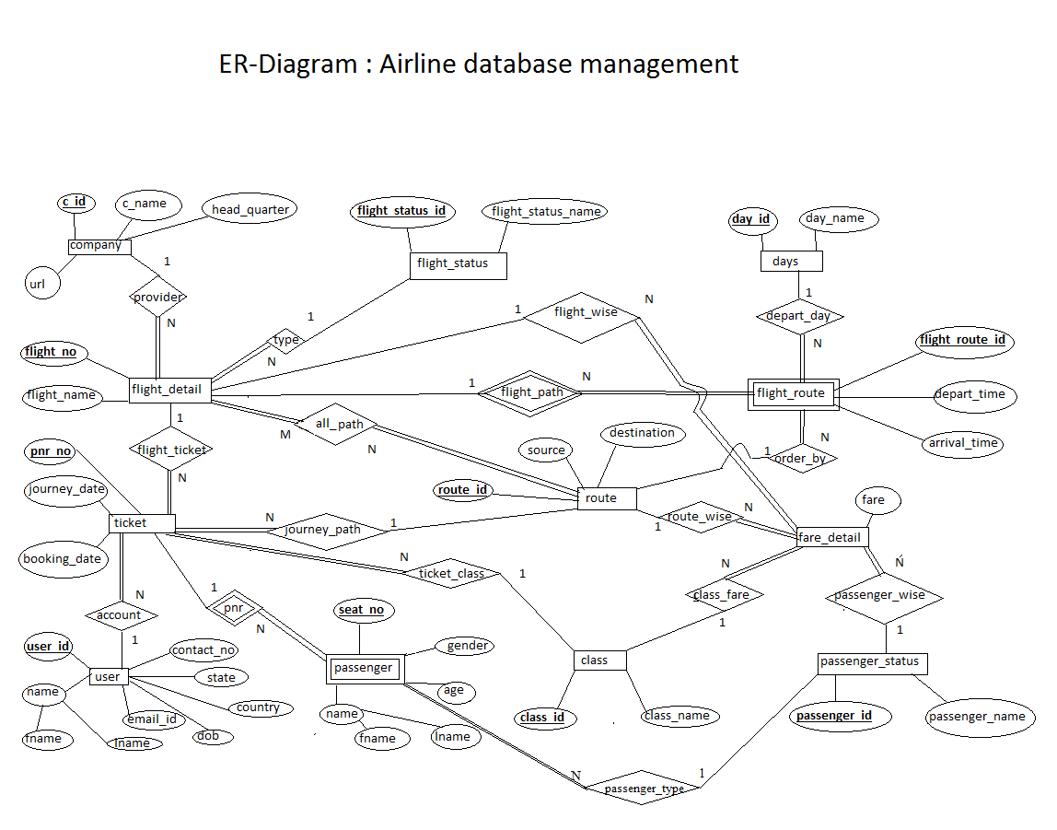

Relation Schema

